**Mckenzie (MJ) Gillman**

**Academic & Athletic Resume**

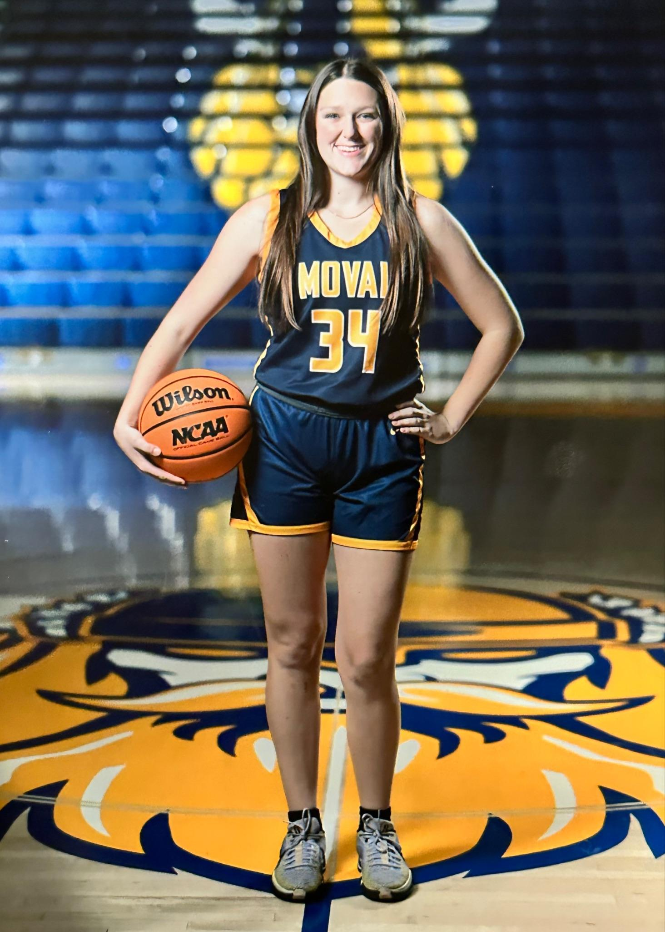

**Instagram:**

**Positions:** Guard/Wing/Stretch 4 **Height:** 5’9”  **Weight:** 150 lbs

***I am a disciplined and motivated scholar athlete with a strong work ethic and a desire to continue my basketball career at the collegiate level. If I could describe my basketball game in 3 words it would be tough, unselfish, and hard working. I am passionate about my love for my teammates and coaches and will do what is needed to help my team win, including diving on the floor for loose balls, take a charge, guard the opposing team's best player and score when needed. I am very coachable and I want to get better and learn at the next level. I come from a winning culture and I plan on continuing that winning culture at the next level.***

**Personal Information**

**Mailing Address:** **Date of Birth:** April 30, 2007

7450 Chateau Ridge Ln **Cell Phone:**  951-218-5022

Riverside, CA 92506 **Email:** [mjgillman34@gmail.com](mailto:mjgillman34@gmail.com)

**Academic Information**

**Name of High School:** Moreno Valley High School

**Moreno Valley Athletics Instagram:** https://www.instagram.com/movalgbb

**Graduation Year:** 2025

**Academic GPA:** 3.83

**Registered with NCAA Eligibility Center:** Yes **Registered Number:** 2303826431

**Intended College Major Area of Study:** Nursing **Future Occupation:** Nursing

**Teams**

**High School Varsity Sports: (Lettered on Varsity all 4 years)**

* Riverside Poly (PHS) Girls’ Varsity Basketball (2 seasons, 2021-2023)
* Moreno Valley High School (MVHS) Girls’ Varsity Basketball (1 season 2023-2024)

**Travel Ball:**

* West Coast Premier 17U Platinum (Spring and Summer 2024)
* West Coast Elite 16U Regional Team (Spring and Summer 2023)

**Coaches and Trainers**

**MVHS GBB Coach:** Larry Wright **Phone:** 951-442-9912 **Email:** [wright.larry1221@gmail.com](mailto:wright.larry1221@gmail.com)

**PHS GBB Coach:** Sid Llera **Phone:** 951-237-1323 **Email:** [sllera@riversideunified.org](mailto:sllera@riversideunified.org)

**West Coast Coach:** Johnny Vasquez **Phone:**  478-973-8359 **Email:** [jsvasquez.24@gmail.com](mailto:jsvasquez.24@gmail.com)

**West Coast Asst. Coach:** Maria Mesa **Phone:** 909-648-0556 **Instagram:** [@coach.maria.mesa](https://www.instagram.com/coach.maria.mesa/)

**Skills Coaches:**

**Brent Summers Phone: 310-404-3715 Instagram: @rim2rimceo**

**Nae Nae Calhoun Phone: 951-398-2926 Instagram: @theydundidit_24**

**(starting PG for Cal Baptist University)**

**Honors, Accomplishments, and Videos**

**Moreno Valley Girls’ Basketball (2023-2024)**

**Team Accomplishments**

* 2023-2024 Record 30-6
  + CIF Runner Up
  + Had 17 points in the championship game
  + Finished the season ranked 18th in the state of California
  + Finished 9th in Southern Section of California
  + Finished Ranked #1 in Los Angeles Metro Rankings
  + Lost in 3rd round of state on the Road by 3 points

**Individual Accomplishments**

* 2023-2024 Second Team All League, 6th Man Of The Year, Scholar Athlete(MVHS)
* 2023-2024 Player Of The Game CIF Championship against St. Anthony Division 2AA

[**2023-2024 GBB Season Schedule**](https://www.maxpreps.com/ca/moreno-valley/moreno-valley-vikings/basketball/girls/schedule/)

**Riverside Poly Girls’ Basketball (2020-2023)**

**Team Accomplishments**

* 2022-2023 CIF Southern Section Girls Basketball Final Polls,

Division 2A, Rank #11 (February 5, 2023) **(**[**Link**](https://cifss.org/rankings/2-5-2023-girls-basketball-poll/?_sports=girls-basketball)**)**

* 2022-2023 CIF Southern Section Division 2A Quarterfinalists
* 2022 Ramona Winter Classic Runner-up (December 30, 2022)
* 2022 Redlands East Valley Tournament Champions (December 3, 2022) **(**[**Link**](https://www.instagram.com/p/Clxnm0hrO8j/)**)**
* 2022 Raincross Tournament Third Place (November 19, 2022)
* 2021-2022 CIF Southern Section Girls Basketball Final Polls,

Division 3AA, Rank #5 (February 8, 2022) **(**[**Link**](https://cifss.org/rankings/2-8-2022-final-girls-basketball-poll/?_sports=girls-basketball)**)**

* 2021-2022 Raincross Conference: Sunbelt League Undefeated Champions **(**[**Link**](https://www.instagram.com/p/Ccj00B9LcDm/)**)**

(First League Title since 1985)

* 2021 Raincross Tournament Runner-up (November 19, 2021)

**Individual Accomplishments**

* 2021-2022 First Team All League, Scholar Athlete(PHS)
* 2022-2023 Scholar Athlete(PHS)

[**2022-2023 GBB Season Schedule**](https://www.maxpreps.com/ca/riverside/poly-bears/basketball/girls/schedule/)

[**2021-2022 GBB Season Schedule**](https://www.maxpreps.com/ca/riverside/poly-bears/basketball/girls/21-22/schedule/)

**Travel Basketball - 17U**

**West Coast Premier - West Coast Premier 17U Platinum**

**Instagram:** [**https://www.instagram.com/whynotpremier/**](https://www.instagram.com/whynotpremier/)

**Travel Basketball - 16U Regional**

**West Coast Elite - West Coast Elite 16U Regional Team**

**Instagram:** [**https://www.instagram.com/wceuagirls**](https://www.instagram.com/wceuagirls)

**Extracurricular/Community Service/Leadership During High School**

**California Baptist University Men’s Basketball Camp - Volunteer Counselor (June 2022)**

* **CBU Assistant Coach/Camp Director:** Geoff McIntosh

**Phone:** 951- 343-4532 **Email:** [gmcintosh@calbaptist.edu](mailto:gmcintosh@calbaptist.edu)

* Session 4 (June 27 - 30)

**Parent/Guardian Information**

| **Parent/Guardian Name:** Gary Gillman  **Cell Phone:** 951-858-5439  **Email:** [**ggillman32@gmail.com**](mailto:ggillman32@gmail.com)  **Occupation: Business Owner**  **Athletics**: Basketball  Morro Bay High School:  Top 5 leading scorer in the State of California (High School), League MVP Central Coast League Junior and Senior year, County Player of the year Junior & Senior year  Played one year at Cuesta Junior College went  To the state final 8, Played one year at the  University of Hawaii, Played 2 years at  California Baptist University 2 time all-conference honors senior year received All-American honors | **Parent/Guardian Name:** Camie Gillman  **Cell Phone:** 951-858-5438  **Email:** [**camers4@hotmail.com**](mailto:camers4@hotmail.com)  **Occupation:** Substitute Teacher/Retired Teacher  **Athletics**: College Water Polo All-American; College National Championship Swimmer; High School Water Polo Coach (CIF SS Playoffs multiple years) Riverside Poly High School; Inaugural women water polo player on both high school 1995-1998 and college team 1999-2002 |
| --- | --- |